**3.Arduino UNO platform-------CarRun**

1. **Preparation**

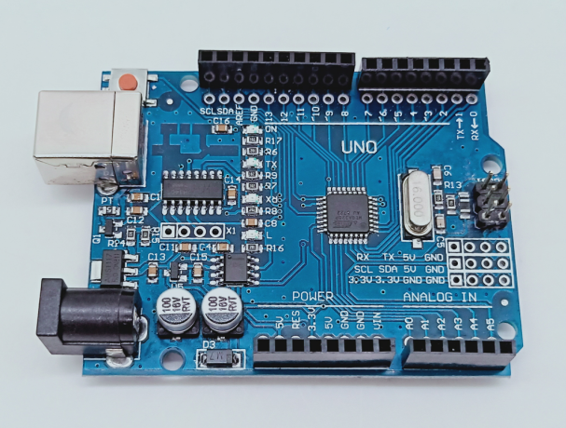

1-1 Arduino UNO board

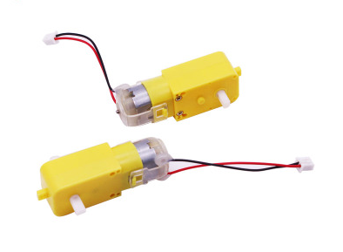

1-2 4 motors

1. **Purpose of Experimental**

After the code upload is completed, the robot car will delay is 2s, advance 1s, back 1s, turn left 2s, turn right 2s, turn left in place 3s, turn right in place 3s, stop 0.5s. And it goes on and on.

1. **Principle of experimental**

We use the TB6612FNG driver chip to drive the motor. Control the forward, reverse, and stop of the motor by controlling the level of AIN1, AIN2, BIN1, BIN2, PWMA, and PWMB of the driver chip.

In this experiment, we control robot car advance by controlling AIN1 to be high level, AIN2 is low level, BIN1 is high level, BIN2 is low level. And we control speed of the robot car by controlling PWMA, PWMB(0-255). One-channel PWM control the speed of the motor on one side of the robot car.

1. **Experimental Steps**

4-1 About the schematic

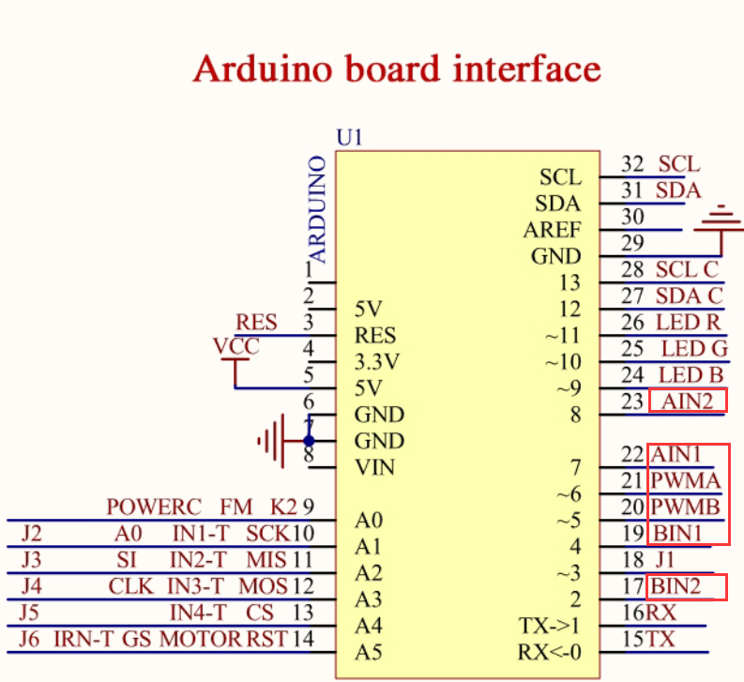

4-1 Arduino UNO interface circuit diagram

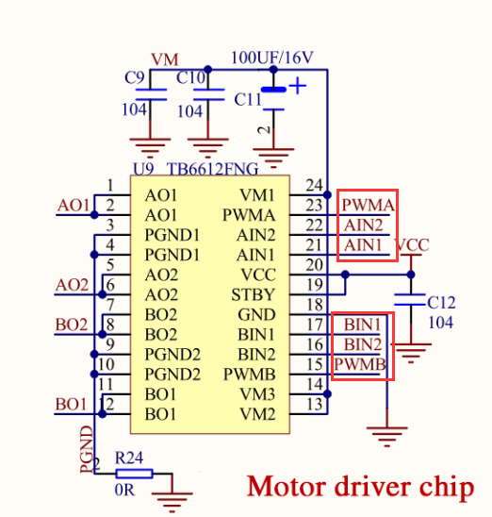

4-2 Motor drive chip---TB6612FNG

4-2 According to the circuit schematic:

AIN1-----7(Arduino UNO)

AIN2-----8(Arduino UNO)

PWMA-----6(Arduino UNO)

BIN1-----4(Arduino UNO)

BIN2-----2(Arduino UNO)

PWMB-----5(Arduino UNO)

4-3 About the code

1. We need to open the code of this experiment: **CarRun.ino**, click“**√**” under the menu bar to compile the code, and wait for the word "**Done compiling** " in the lower right corner, as shown in the figure below.

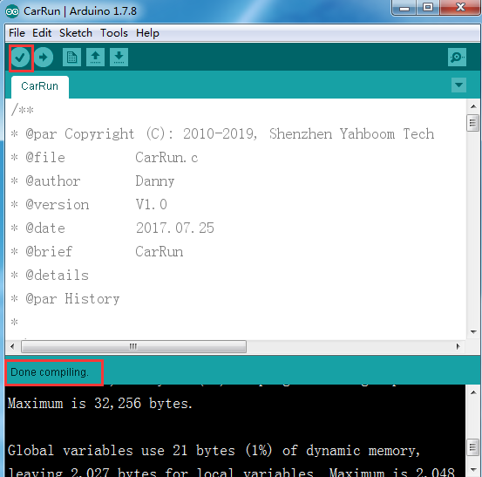

2.In the menu bar of Arduino IDE, we need to select 【Tools】---【Port】--- selecting the port that the serial number displayed by the device manager just now, as shown in the figure below.

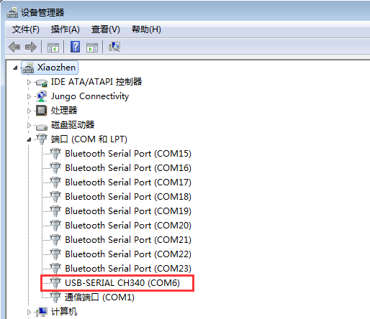

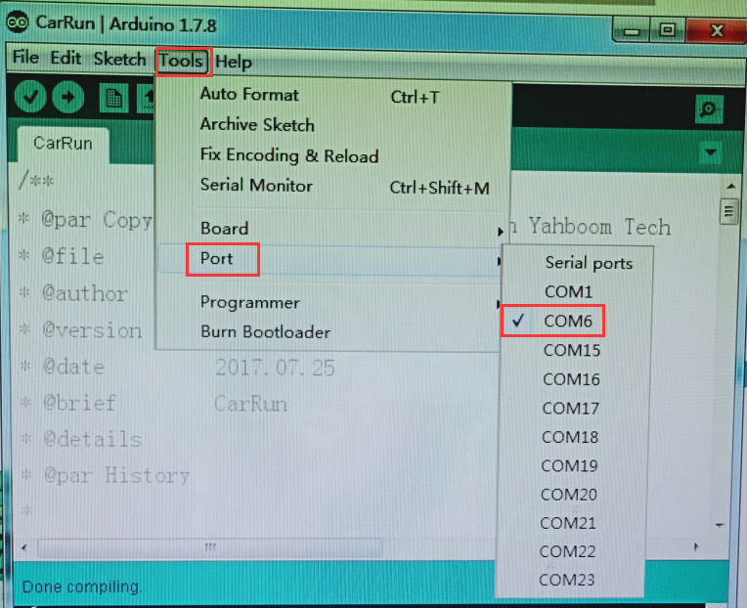

3.After the selection is completed, you need to click “**→**”under the menu bar to upload the code to the Arduino UNO board. When the word “**Done uploading**” appears in the lower left corner, the code has been successfully uploaded to the Arduino UNO board, as shown in the figure below.

